**RESUME**

**NAGESH POPLAYAT**

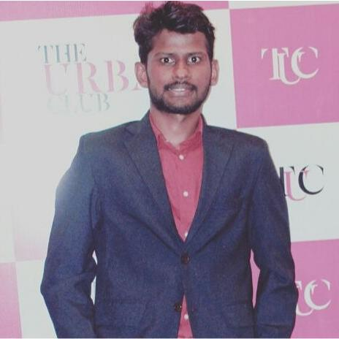

|  |  |  |  |  |  |
| --- | --- | --- | --- | --- | --- |
|  | **Address** |  |  | **Contact Details** |  |
|  | House No. C-17 | |  | Mobile No.: 9860279259 | |
| Surajban Society, | | | Email : nnageshpoplayat@gmail.com | | |
|  | Aundh Pune 411007 | |  |  |  |



**Career Objective:**

To work with an organization offering a responsible, challenging and creative work profile and a continuous learning environment that would help me build a strong and successful career.

**Academic Details:**

|  |  |  |  |  |
| --- | --- | --- | --- | --- |
| Currently studying at AISSMS IOIT Pune. | | |  |  |
| Sr. No. | Class & Branch | Board/Universi | Year of | Grade/% |
|  |  | ty | Passing |  |
| 1. | BE | PUNE | 2017-18 | 69.60% |
| 2. | 12th | CBSE | 2014 | 73.20% |
| 3. | 10th | CBSE | 2012 | 8.4,CGPA |

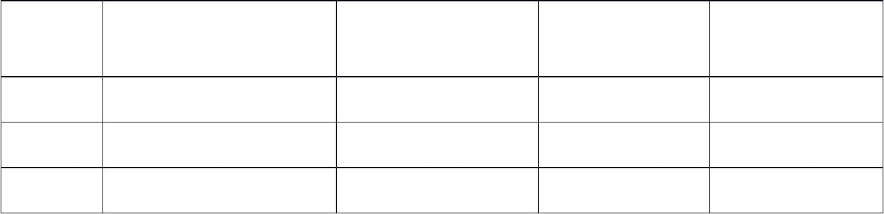

**Skill Set**

* + JAVA.
  + OOPS CONCEPT.
  + C.
  + XML.
  + MYSQL.
    - DATA STRUCTURE

1

**Achievements:**

* + - Got selected for JNV PROGRAM.
  + Two times House Leadership in JNV PROGRAM.
  + First Rank in Group Dance competition at School level.
  + Two times NATIONAL LEVEL KHO-KHO PARTICIPATION.

Internship at VST INFOTECH Shivajinagar Pune.

**Projects Completed:**

* + - Created an app For HANDICAP PEOPLE- MOUSE MOVEMENT USING EYE TRACKING.

Processor Used- PENTIUM-|||.

Platform- Windows 7 Monitor- SVGA. Language- JAVA.

Technology- JMF(Java Media Framework)

**EXTRA – CURRICULAR ACTIVITIES**

* + - Member of Alacrity, College Event at AISSMS IOIT College (2015 – 2016).
    - Opener Batsman for college cricket Team.
  + Volunteered multiple events in college fests over the span of three academic years.

**INTEREST & HOBBIES**

Cricket Enthusiast.

* + - * + Interested in Gaming.
        + Interested in playing musical instruments.

2

**Personal Details:**

I just want to learn new technologys.

am a learner and i want to part of something new,something incredible.

make mi feel i did something in my life and made some impact my life and of others.

* Date of Birth: 15 March, 1996.
* Nationality: Indian.
* Permanent Address: Mahadev Nagar, Halli, Dist-Latur.

3